**Metropolitan Housing Trust Ltd / Metropolitan Funding PLC**

**Thames Valley Housing Association (TVHA), trading as MTVH, announces trading update and unaudited consolidated financial results for the six months ended 30 September 2024**

***Continued strong performance in a challenging environment***

**Overview and highlights**

* Total revenue increased to £227m (H1 24: £209m)
  + Revenue from rent and service charges £191m (H1 24: £175m) driven by the government’s social rent increase of 7.7%
  + Higher sales of new homes (147 H1 25 vs 116 H1 24) resulted in £4m increase in sales revenue year-on-year
* Operating surplus £61m (H1 24: £75m) reflecting £20m lower surplus from fixed asset disposals year on year. Accordingly:
  + Operating margin decreased to 27% (H1 24: 36%)
* Total surplus* was £14m (H1 24: £35m).
* Increased investment in the safety and quality of our residents’ homes
  + We invested £20m in capitalised improvement works to our estate (H1 24: £16m)
  + Gross fire safety spend in H1 was £8m (H1 24: £6m).
* Our Tenant Satisfaction Measures (TSM) show that we are ahead of peers in overall satisfaction and treating customers with fairness and respect.
  + We continue to use our Customer Voice Framework to provide meaningful opportunities for residents to engage with us on TSM topics and influence our decisions.
* Our development programme is on track to deliver 569 new homes in the full year through partnership projects such as Clapham Park.
  + In H1 25 we completed 236 new homes (H1 24: 293)
  + Sales of 147 units completed (H1 24: 116)
* Our financial position remains strong and supports our strategy for continued sustainable growth.
  + £675m (March 24: £846m) of available liquidity.
  + Improved S&P Group rating of A- (Stable outlook), following the MTVH Rating Review in December 2023.
  + Fitch Ratings downgraded the rating as A- (Stable outlook) in September 2024.
  + Ritterwald refreshed the Sustainable Housing Certification, moving MTVH up to Frontrunner for all criteria covering Social and Governance, and now Environmental criteria.

*As a not-for-profit Registered Provider our Total Surplus is re-invested to maintain existing homes and build more new homes

Mel Barrett, Chief Executive, commented:

“Our half year results reflect our resilient business model and strong balance sheet which have allowed us to invest in existing stock, deliver fire safety remediation, look after our residents, and continue to develop new homes.

We have provided record levels of financial support to our customers through our Tenant Welfare Fund and having launched the Molly Huggins Foundation in July we will do more by leveraging the support of commercial partners and charitable donors.

We completed 236 homes in the first half of the year and are on track to deliver 569 in the full year. We will also invest a record amount this year in new developments, to help build the new affordable homes that the country badly needs.

Our strong first half performance leaves us confident for the full year outcome and our robust financial position is underscored by the A- (stable) ratings awarded by S&P and Fitch Ratings.

We welcome the rent settlement of CPI+1% confirmed in the Budget and urge the government to increase direct revenue funding at the Spring Spending Review to allow our sector to support its homebuilding plans.”

**Segmental performance**

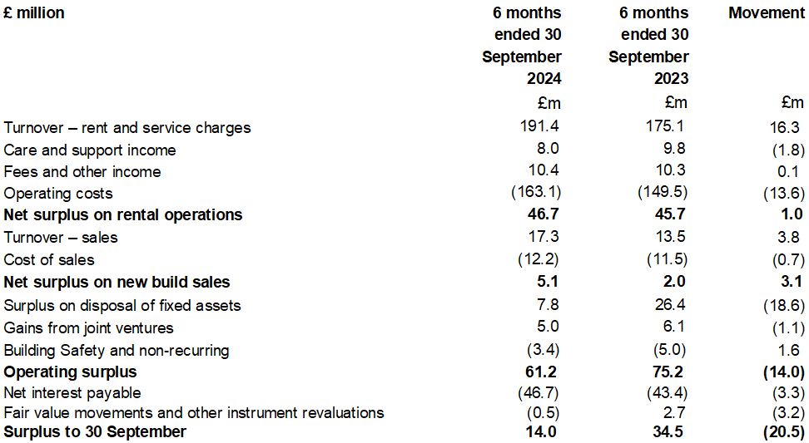

**Senior Leadership Changes**

Mel Barrett was appointed Chief Executive Officer, replacing Geeta Nanda OBE, and joined the organisation at the start of September 2024.

**Trading overview**

Total revenue including home sales is c 9% higher than last year as a result of the 7.7% rent increases and higher sales revenues from First Tranche Sales. Care & Support income has reduced as we took the strategic decision to exit CQC-registered contracts to focus on a new approach to supported housing and living which helps people in their own homes, and more closely aligns to our core function as a social landlord.

Turnover from sales was higher as we sold 147 units in the first six months (compared to 116 in the same period last year). At 30 September 2024, we had 136 unsold units, of which only 58 are unsold over 90 days, with a sales value of £5.8m. While sales are currently in line with expectations, we remain well-placed if the sales market weakens.

Net surplus from rental operations (ie net rents less total operating costs) for the first half of FY25 was 5% higher than last year, reflecting strong cost control in a high inflation and increasingly challenging service environment. Gross margin from First Tranche sales more than doubled compared to the same period last year to £5.1m, achieving a 29% sales margin (H1 24: 15%).

Operating costs in the first six months were £163m (H1 24: £150m). Year on year inflationary pressure also increased costs relating to salaries, utilities and managing agents. Surplus from the disposal of fixed assets was down £20m compared to the first half of FY24 at £13m. Most of this reduction is represented by the two bulk disposals we made in H1 24, which together realised £18m surplus. Staircasing surplus was also down £1.4m compared to H1 last year, although these have picked up in the second quarter. Total surplus from disposals this year remains in line with our business plan. Operating margin (including non-recurring safer building costs) for the first six months is 9.0 ppts lower at 27.0% (H1 24 36.0%) as a result of the lower disposal surplus.

Cashflow from operations was £5m higher than H1 last year. Disposal proceeds are £56m lower than last year because of the one-off bulk deals in H1 24. Net investment in new development projects totalled £177m (H1 24: £89m) due to some significant project spend being delayed from last year into Q125, including Meridian Water phase 2 and our Shared Ownership scheme at One Nine Elms*.* The organisation completed 236 homes during the first half of the year (H1 24: 293) and remains on track to deliver around 569 new homes for the full year.

Net interest costs (excluding mark to market movements on derivatives) are £3m higher than the same period last year due to higher levels of net debt and higher variable rates, although interest expense has been mitigated by used of short term interest rate swaps. At 30 September 2024, we had £675m of available liquidity (both cash and committed facilities) (Mar 24: £846m) as we have drawn funds to cover development spend, resulting in total debt of £2.1bn (Mar 24 £1.9bn). We have agreed commercial terms to secure £150m of additional facilities with signing expected before the end of the calendar year. Liquidity management remains a key focus to mitigate the impact of a wider economic downturn. At the same time, our relatively low gearing, at 39%, and nearly £610m of available security, provides further resilience to shock.

Thames Valley Housing Association’s Standard & Poor’s credit rating was unchanged in December 2023 at A- with the outlook improving to Stable. Fitch Ratings downgraded the organisation rating to A- (Stable) in October 2024.

**Full-year outlook**

This outlook statement is subject to uncertainty/unforeseen market and business interruption as a result of uncertainty over the direction of government policy. The economic and geopolitical environments remain challenging, with persistently high levels of inflation and interest rates as well as continuing concerns over energy costs. The recent budget changes to National Insurance contributions and the Living Wage will increase our costs next year by around £3m.

Trading

Full year turnover and operating surplus is expected to be in line with our budget. Surplus from asset disposals is weighted towards H2, including a significant land disposal at Clapham Park which completed in November.

Looking further forward, the rent regime of CPI+1% effective from April 2025 is expected to result in an increase of 2.7% to our social rents for FY26. This will boost revenues, but margins will continue to be under pressure as operating costs are forecast to rise at a higher rate, along with the £3m increase in our National Insurance costs. The core housing business is expected to perform in line with our business plan expectations.

We expect to invest a record amount in new homes development as part of our current programme to build around 1,000 new homes per year, however without an increase in direct revenue support from the government our capacity to build new homes will be limited. MTVH remain committed to providing increased support for those residents who face financial hardship.

Investment in building safety

Fire safety and damp and mould works have increased investment to our existing homes. This is a sector issue. The longer-term impact of remediation obligations has led to a reduction in our capacity to develop new homes, particularly homes for sale.

We are continuing with our Safer Buildings programme driven by our desire to put customer safety first. We expect that developers/warranty providers will pick up the costs of remediation for newer buildings where this relates to construction defect. We will seek to either accelerate the remediation or redevelop the at-risk blocks, having confirmed we would not seek recovery from qualifying leaseholders and the costs of this has been fully expensed in our 2024 Statutory Accounts.

TVHA/MHT (trading as MTVH) will report results for the year ended 31 March 2025, in summer 2025.

**Consolidated financials**

**Statement of comprehensive income**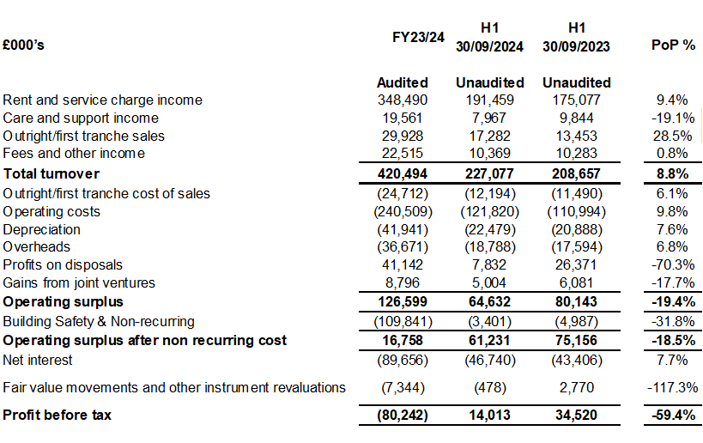

**Statement of Financial Position**



**Cashflow**



**Enquiries**

Please contact Donald McKenzie, Director of Corporate Finance, on 0203-535-4434/ 07738-714126 or at donald.mckenzie@mtvh.co.uk

This information for investors is also available on our website:

https://www.mtvh.co.uk/about-us/investors/

**Notes**

1. Operating margin is operating surplus/turnover
2. Thames Valley Housing Association (TVHA) is the parent of the group trading under the brand of Metropolitan Thames Valley (MTVH). Metropolitan Housing Trust (MHT) is a wholly owned subsidiary of TVHA and MHT owns 100% of the shares of Metropolitan Funding Plc.

**Disclaimer**

The information in this announcement of unaudited consolidated interim results has been prepared by the Thames Valley Housing Association group and is for information purposes only.

The unaudited results announcement should not be construed as an offer or solicitation to buy or sell any securities, or any interest in any such securities, and nothing herein should be construed as a recommendation or advice to invest in any such securities.

This unaudited results announcement contains certain ‘forward-looking’ statements reflecting, among other things, our current views on markets, activities and prospects. By their nature, forward looking statements involve a number of risks, uncertainties or assumptions that could cause actual results to differ materially from those expressed or implied by those statements. Actual outcomes may differ materially. Such statements are a correct reflection of our views only on the publication date and no representation or warranty is given in relation to them, including as to their completeness or accuracy or the basis on which they were prepared. Financial results quoted are unaudited. We do not undertake to update or revise such public statements as our expectations change in response to events. Accordingly undue reliance should not be placed on forward looking statements.